Horizon Europe Programme

Standard Proposal Template (RIA, IA)_Commentato per utenti UMIL

Project proposal – Technical description (Part B)

Version 1.0
10 March 2021

Structure of the Proposal

The proposal contains two parts:

• Part A of the proposal is generated by the IT system. It is based on the information entered by the participants through the submission system in the Funding & Tenders Portal. The participants can update the information in the submission system at any time before final submission.

• Part B of the proposal is the narrative part that includes three sections that each correspond to an evaluation criterion. Part B needs to be uploaded as a PDF document following the templates downloaded by the applicants in the submission system for the specific call or topic. The templates for a specific call may slightly differ from the example provided in this document.

The electronic submission system is an online wizard that guides you step-by-step through the preparation of your proposal. The submission process consists of 6 steps:

- Step 1: Logging in the Portal
- Step 2: Select the call, topic and type of action in the Portal
- Step 3: Create a draft proposal: Title, acronym, summary, main organisation and contact details
- Step 4: Manage your parties and contact details: add your partner organisations and contact details.
- Step 5: Edit and complete web forms for proposal part A and upload proposal part B
- Step 6: Submit the proposal

Proposal template Part B: technical description
(for full proposals: single stage submission procedure and 2nd stage of a two-stage submission procedure)

This template is to be used in a single-stage submission procedure or at the 2nd stage of a two-stage submission procedure.
The structure of this template must be followed when preparing your proposal. It has been designed to ensure that the important aspects of your planned work are presented in a way that will enable the experts to make an effective assessment against the evaluation criteria. Sections 1, 2 and 3 each correspond to an evaluation criterion.
Please be aware that proposals will be evaluated as they were submitted, rather than on their potential if certain changes were to be made. This means that only proposals that successfully address all the required aspects will have a chance of being funded. There will be no possibility for significant changes to content, budget and consortium composition during grant preparation.
Page limit: The title, list of participants and sections 1, 2 and 3, together, should not be longer than 45 pages. The page limit will be applied automatically. All tables, figures, references and any other element pertaining to these sections must be included as an integral part of these sections and are thus counted against this page limit. The number of pages included in each section of this template is only indicative.
The page limit will be applied automatically. At the end of this document you can see the structure of the actual proposal that you need to submit, please remove all instruction pages that are watermarked.
Instructions, please remove
If you attempt to upload a proposal longer than the specified limit before the deadline, you will receive an automatic warning and will be advised to shorten and re-upload the proposal. After the deadline, excess pages (in over-long proposals/applications) will be automatically made invisible, and will not be taken into consideration by the experts. The proposal is a self-contained document. Experts will be instructed to ignore hyperlinks to information that is specifically designed to expand the proposal, thus circumventing the page limit.
Please, do not consider the page limit as a target! It is in your interest to keep your text as concise as possible, since experts rarely view unnecessarily long proposals in a positive light.
The following formatting conditions apply.
The reference font for the body text of proposals is Times New Roman (Windows platforms), Times/Times New Roman (Apple platforms) or Nimbus Roman No. 9 L (Linux distributions).
The use of a different font for the body text is not advised and is subject to the cumulative conditions that the font is legible and that its use does not significantly shorten the representation of the proposal in number of pages compared to using the reference font (for example with a view to bypass the page limit).
The minimum font size allowed is 11 points. Standard character spacing and a minimum of single line spacing is to be used. This applies to the body text, including text in tables.
Text elements other than the body text, such as headers, foot/end notes, captions, formula's, may deviate, but must be legible.
The page size is A4, and all margins (top, bottom, left, right) should be at least 15 mm (not including any footers or headers).

DEFINITIONS
Critical risk | A critical risk is a plausible event or issue that could have a high adverse impact on the ability of the project to achieve its objectives.  Level of likelihood to occur (Low/medium/high): The likelihood is the estimated probability that the risk will materialise even after taking account of the mitigating measures put in place.  Level of severity (Low/medium/high): The relative seriousness of the risk and the significance of its effect.
Deliverable | A report that is sent to the Commission or Agency providing information to ensure effective monitoring of the project. There are different types of deliverables (e.g. a report on specific activities or results, data management plans, ethics or security requirements).
Impacts | Example: The deployment of the advanced forecasting system enables each airport to increase maximum passenger capacity by 15% and passenger average throughput by 10%, leading to a 28% reduction in infrastructure expansion costs.
Milestone | Control points in the project that help to chart progress. Milestones may correspond to the achievement of a key result, allowing the next phase of the work to begin. They may also be needed at intermediary points so that, if problems have arisen, corrective measures can be taken. A milestone may be a critical decision point in the project where, for example, the consortium must decide which of several technologies to adopt for further development. The achievement of a milestone should be verifiable.
Objectives | The goals of the work performed within the project, in terms of its research and innovation content. This will be translated into the project’s results. These may range from tackling specific research questions, demonstrating the feasibility of an innovation, sharing knowledge among stakeholders on specific issues. The nature of the objectives will depend on the type of action, and the scope of the topic.  Instructions, please remove
Outcomes | The expected effects, over the medium term, of projects supported under a given topic. The results of a project should contribute to these outcomes, fostered in particular by the dissemination and exploitation measures. This may include the uptake, diffusion, deployment, and/or use of the project’s results by direct target groups. Outcomes generally occur during or shortly after the end of the project.  Example: 9 European airports adopt the advanced forecasting system demonstrated during the project.
Pathway to impact | Logical steps towards the achievement of the expected impacts of the project over time, in particular beyond the duration of a project. A pathway begins with the projects’ results, to their dissemination, exploitation and communication, contributing to the expected outcomes in the work programme topic, and ultimately to the wider scientific, economic and societal impacts of the work programme destination.
Research output | Results generated by the action to which access can be given in the form of scientific publications, data or other engineered outcomes and processes such as software, algorithms, protocols and electronic notebooks.
Results | What is generated during the project implementation. This may include, for example, know-how, innovative solutions, algorithms, proof of feasibility, new business models, policy recommendations, guidelines, prototypes, demonstrators, databases and datasets, trained researchers, new infrastructures, networks, etc. Most project results (inventions, scientific works, etc.) are ‘Intellectual Property’, which may, if appropriate, be protected by formal ‘Intellectual Property Rights’.  Example: Successful large-scale demonstrator: trial with 3 airports of an advanced forecasting system for proactive airport passenger flow management.
Technology Readiness Level | See Work Programme General Annexes B
Fill in the title of your proposal below.

Title of the Proposal
The consortium members are listed in part A of the proposal (application forms). A summary list should also be provided in the table below.
List of participants
Participant No. * | Participant organisation name  Instructions, please remove | Country

1 (Coordinator)

2

3
* Please use the same participant numbering and name as that used in the administrative proposal forms.

Excellence – aspects to be taken into account.
- Clarity and pertinence of the project’s objectives, and the extent to which the proposed work is ambitious, and goes beyond the state of the art.
- Soundness of the proposed methodology, including the underlying concepts, models, assumptions, interdisciplinary approaches, appropriate consideration of the gender dimension in research and innovation content, and the quality of open science practices, including sharing and management of research outputs and engagement of citizens, civil society and end users where appropriate.

1. Excellence
- The following aspects will be taken into account only to the extent that the proposed work is within the scope of the work programme topic.
Instructions, please remove
1.1 Objectives and ambition [e.g. 4 pages]
- Briefly describe the objectives of your proposed work. Why are they pertinent to the work programme topic? Are they measurable and verifiable? Are they realistically achievable?
- Describe how your project goes beyond the state-of-the-art, and the extent the proposed work is ambitious. Indicate any exceptional ground-breaking R&I, novel concepts and approaches, new products, services or business and organisational models. Where relevant, illustrate the advance by referring to products and services already available on the market. Refer to any patent or publication search carried out.
- Describe where the proposed work is positioned in terms of R&I maturity (i.e. where it is situated in the spectrum from ‘idea to application’, or from ‘lab to market’). Where applicable, provide an indication of the Technology Readiness Level, if possible distinguishing the start and by the end of the project.
- Please bear in mind that advances beyond the state of the art must be interpreted in the light of the positioning of the project. Expectations will not be the same for RIAs at lower TRL, compared with Innovation Actions at high TRLs.
1.2 Methodology [e.g. 15 pages]
- Describe and explain the overall methodology, including the concepts, models and assumptions that underpin your work. Explain how this will enable you to deliver your project’s objectives. Refer to any important challenges you may have identified in the chosen methodology and how you intend to overcome them. [e.g. 10 pages]
- This section should be presented as a narrative. The detailed tasks and work packages are described below under ‘Implementation’.
- Where relevant, include how the project methodology complies with the ‘do no significant harm’ principle as per Article 17 of Regulation (EU) No 2020/852 on the establishment of a framework to facilitate sustainable investment (i.e. the so-called 'EU Taxonomy Regulation'). This means that the methodology is designed in a way it is not significantly harming any of the six environmental objectives of the EU Taxonomy Regulation.
Describe any national or international research and innovation activities whose results will feed into the project, and how that link will be established; [e.g. 1 pages]
- Explain how expertise and methods from different disciplines will be brought together and integrated in pursuit of your objectives. If you consider that an inter-disciplinary approach is unnecessary in the context of the proposed work, please provide a justification. [e.g. 1/2 page]
- For topics where the work programme indicates the need for the integration of social sciences and humanities, show the role of these disciplines in the project or provide a justification if you consider that these disciplines are not relevant to your proposed project. [e.g. 1/2 page]
- Describe how the gender dimension (i.e. sex and/or gender analysis) is taken into account in the project’s research and innovation content [e.g. 1 page]. If you do not consider such a gender dimension to be relevant in your project, please provide a justification.
- Note: This section is mandatory except for topics which have been identified in the work programme as not requiring the integration of the gender dimension into R&I content.
Instructions, please remove
- Remember that that this question relates to the content of the planned research and innovation activities, and not to gender balance in the teams in charge of carrying out the project.
- Sex and gender analysis refers to biological characteristics and social/cultural factors respectively. For guidance on methods of sex / gender analysis and the issues to be taken into account, please refer to http://ec.europa.eu/research/swafs/gendered-innovations/index_en.cfm?pg=home
Describe how appropriate open science practices are implemented as an integral part of the proposed methodology. Show how the choice of practices and their implementation are adapted to the nature of your work, in a way that will increase the chances of the project delivering on its objectives [e.g. 1 page]. If you believe that none of these practices are appropriate for your project, please provide a justification here.
- Open science is an approach based on open cooperative work and systematic sharing of knowledge and tools as early and widely as possible in the process. Open science practices include early and open sharing of research (for example through preregistration, registered reports, pre-prints, or crowd-sourcing); research output management; measures to ensure reproducibility of research outputs; providing open access to research outputs (such as publications, data, software, models, algorithms, and workflows); participation in open peer-review; and involving all relevant knowledge actors including citizens, civil society and end users in the co-creation of R&I agendas and contents (such as citizen science).
- Please note that this question does not refer to outreach actions that may be planned as part of communication, dissemination and exploitation activities. These aspects should instead be described below under ‘Impact’.
Research data management and management of other research outputs: Applicants generating/collecting data and/or other research outputs (except for publications) during the project must provide maximum 1 page on how the data/ research outputs will be managed in line with the FAIR principles (Findable, Accessible, Interoperable, Reusable), addressing the following (the description should be specific to your project): [1 page]
Types of data/research outputs (e.g. experimental, observational, images, text, numerical) and their estimated size; if applicable, combination with, and provenance of, existing data.
Findability of data/research outputs: Types of persistent and unique identifiers (e.g. digital object identifiers) and trusted repositories that will be used.
Accessibility of data/research outputs: IPR considerations and timeline for open access (if open access not provided, explain why); provisions for access to restricted data for verification purposes.
Interoperability of data/research outputs: Standards, formats and vocabularies for data and metadata.
Reusability of data/research outputs: Licenses for data sharing and re-use (e.g. Creative Commons, Open Data Commons); availability of tools/software/models for data generation and validation/interpretation /re-use.
Instructions, please remove
Curation and storage/preservation costs; person/team responsible for data management and quality assurance.
- Proposals selected for funding will need to develop a first detailed data management plan (DMP) for making their data/research outputs findable, accessible, interoperable and reusable (FAIR) at the latest before the signature of the grant agreement and as a deliverable by week 1 of the project
- For guidance on open science practices and research data management, please refer to the relevant section of the HE Programme Guide on the Funding & Tenders Portal.
2. Impact
Impact – aspects to be taken into account.
- Credibility of the pathways to achieve the expected outcomes and impacts specified in the work programme, and the likely scale and significance of the contributions due to the project.
- Suitability and quality of the measures to maximise expected outcomes and impacts, as set out in the dissemination and exploitation plan, including communication activities.
The results of your project should make a contribution to the expected outcomes set out for the work programme topic over the medium term, and to the wider expected impacts set out in the ‘destination’ over the longer term.
In this section you should show how your project could contribute to the outcomes and impacts described in the work programme, the likely scale and significance of this contribution, and the measures to maximise these impacts.
2.1 Project’s pathways towards impact [e.g. 4 pages]
- Provide a narrative explaining how the project’s results are expected to make a difference in terms of impact, beyond the immediate scope and duration of the project. The narrative should include the components below, tailored to your project.
- Describe the unique contribution your project results would make towards (1) the outcomes specified in this topic, and (2) the wider impacts, in the longer term, specified in the respective destinations in the work programme.
- Be specific, referring to the effects of your project, and not R&I in general in this field.
- State the target groups that would benefit. Even if target groups are mentioned in general terms in the work programme, you should be specific here, breaking target groups into particular interest groups or segments of society relevant to this project.
- The outcomes and impacts of your project may:
        - Scientific, e.g. contributing to specific scientific advances, across and within disciplines, creating new knowledge, reinforcing scientific equipment and instruments, computing systems (i.e. research infrastructures);
Instructions, please remove
        - Economic/technological, e.g. bringing new products, services, business processes to the market, increasing efficiency, decreasing costs, increasing profits, contributing to standards’ setting, etc.
        - Societal , e.g. decreasing CO₂ emissions, decreasing avoidable mortality, improving policies and decision making, raising consumer awareness.
Only include such outcomes and impacts where your project would make a significant and direct contribution. Avoid describing very tenuous links to wider impacts. However, include any potential negative environmental outcome or impact of the project including when expected results are brought at scale (such as at commercial level). Where relevant, explain how the potential harm can be managed.
- Describe any requirements and potential barriers - arising from factors beyond the scope and duration of the project - that may determine whether the desired outcomes and impacts are achieved. These may include, for example, other R&I work within and beyond Horizon Europe; regulatory environment; targeted markets; user behaviour. Indicate if these factors might evolve over time. Describe any mitigating measures you propose, within or beyond your project, that could be needed should your assumptions prove to be wrong, or to address identified barriers.
- Note that this does not include the critical risks inherent to the management of the project itself , which should be described below under ‘Implementation’.
- Give an indication of the scale and significance of the project’s contribution to the expected outcomes and impacts, should the project be successful. Provide quantified estimates where possible and meaningful.
- ‘Scale’ refers to how widespread the outcomes and impacts are likely to be. For example, in terms of the size of the target group, or the proportion of that group, that should benefit over time; ‘Significance’ refers to the importance, or value, of those benefits. For example, number of additional healthy life years; efficiency savings in energy supply.
- Explain your baselines, benchmarks and assumptions used for those estimates. Wherever possible, quantify your estimation of the effects that you expect from your project. Explain assumptions that you make, referring for example to any relevant studies or statistics. Where appropriate, try to use only one methodology for calculating your estimates: not different methodologies for each partner, region or country (the extrapolation should preferably be prepared by one partner).
- Your estimate must relate to this project only - the effect of other initiatives should not be taken into account.
2.2 Measures to maximise impact - Dissemination, exploitation and communication [e.g. 5 pages]
- Describe the planned measures to maximise the impact of your project by providing a first version of your ‘plan for the dissemination and exploitation including communication activities’. Describe the dissemination, exploitation and communication measures that are planned, and the target group(s) addressed (e.g. scientific community, end users, financial actors, public at large).
- Please remember that this plan is an admissibility condition, unless the work programme topic explicitly states otherwise. In case your proposal is selected for funding, a more detailed ‘plan for dissemination and exploitation including communication activities’ will need to be provided as a mandatory project deliverable within 6 months after signature date. This plan shall be periodically updated in alignment with the project’s progress.
- Communication measures should promote the project throughout the full lifespan of the project. The aim is to inform and reach out to society and show the activities performed, and the use and the benefits the project will have for citizens. Activities must be strategically planned, with clear objectives, start at the outset and continue through the lifetime of the project. The description of the communication activities needs to state the main messages as well as the tools and channels that will be used to reach out to each of the chosen target groups.
Instructions, please remove
- All measures should be proportionate to the scale of the project, and should contain concrete actions to be implemented both during and after the end of the project, e.g. standardisation activities. Your plan should give due consideration to the possible follow-up of your project, once it is finished. In the justification, explain why each measure chosen is best suited to reach the target group addressed. Where relevant, and for innovation actions, in particular, describe the measures for a plausible path to commercialise the innovations.
- If exploitation is expected primarily in non-associated third countries, justify by explaining how that exploitation is still in the Union’s interest.
- Describe possible feedback to policy measures generated by the project that will contribute to designing, monitoring, reviewing and rectifying (if necessary) existing policy and programmatic measures or shaping and supporting the implementation of new policy initiatives and decisions.

- Outline your strategy for the management of intellectual property, foreseen protection measures, such as patents, design rights, copyright, trade secrets, etc., and how these would be used to support exploitation.
- If your project is selected, you will need an appropriate consortium agreement to manage (amongst other things) the ownership and access to key knowledge (IPR, research data etc.). Where relevant, these will allow you, collectively and individually, to pursue market opportunities arising from the project.
- If your project is selected, you must indicate the owner(s) of the results (results ownership list) in the final periodic report.

2.3 Summary
Provide a summary of this section by presenting in the canvas below the key elements of your project impact pathway and of the measures to maximise its impact.
KEY ELEMENT OF THE IMPACT SECTION
SPECIFIC NEEDS
What are the specific needs that triggered this project?

Example 1
Most airports use process flow-oriented models based on static mathematical values limiting the optimal management of passenger flow and hampering the accurate use of the available resources to the actual demand of passengers.

Example 2
Electronic components need to get smaller and lighter to match the expectations of the end-users. At the same time there is a problem of sourcing of raw materials that has an environmental impact.

D & E & C MEASURES
What dissemination, exploitation and communication measures will you apply to the results?

Example 1
Exploitation: Patenting the algorithmic model.

Dissemination towards the scientific community and airports: Scientific publication with the results of the large-scale demonstration.

Communication towards citizens: An event in a shopping mall to show how the outcomes of the action are relevant to our everyday lives.

Example 2
Exploitation of the new product: Patenting the new product;
Licencing to major electronic companies.

Dissemination towards the scientific community and industry:
Participating at conferences; Developing a platform of material compositions for industry; Participation at EC project portfolios to disseminate the results as part of a group and maximise the visibility vis-à-vis companies.

EXPECTED RESULTS
What do you expect to generate by the end of the project?

Example 1
Successful large-scale demonstrator:
Successful large-scale demonstrator: Trial with 3 airports of an advanced forecasting system for proactive airport passenger flow management.
Instructions, please remove

Algorithmic model:
Novel algorithmic model for proactive airport passenger flow management.

Example 2
Publication of a scientific discovery on transparent electronics.

New product: More sustainable electronic circuits.

Three PhD students trained.

TARGET GROUPS
Who will use or further up-take the results of the project? Who will benefit from the results of the project?

Example 1
9 European airports:
Schiphol, Brussels airport, etc.

The European Union aviation safety agency.

Air passengers (indirect).

Example 2
End-users: consumers of electronic devices.

Major electronic companies: Samsung, Apple, etc.

Scientific community (field of transparent electronics).

OUTCOMES
What change do you expect to see after successful dissemination and exploitation of project results to the target group(s)?

Example 1
Up-take by airports: 9 European airports adopt the advanced forecasting system demonstrated during the project.
Instructions, please remove
Example 2
High use of the scientific discovery published (measured with the relative rate of citation index of project publications).

A major electronic company (Samsung or Apple) exploits/uses the new product in their manufacturing.

IMPACTS
What are the expected wider scientific, economic and societal effects of the project contributing to the expected impacts outlined in the respective destination in the work programme?

Example 1
Scientific: New breakthrough scientific discovery on passenger forecast modelling.

Economic: Increased airport efficiency
Size: 15% increase of maximum passenger capacity in European airports, leading to a 28% reduction in infrastructure expansion costs.

Example 2
Scientific: New breakthrough scientific discovery on transparent electronics.

Economic/Technological: A new market for touch enabled electronic devices.

Societal: Lower climate impact of electronics manufacturing (including through material sourcing and waste management).

- Quality and efficiency of the implementation
Award criteria – aspects to be taken into account
- Quality and effectiveness of the work plan, assessment of risks, and appropriateness of the effort assigned to work packages, and the resources overall
- Capacity and role of each participant, and extent to which the consortium as a whole brings together the necessary expertise.

3.1 Work plan and resources [e.g. 14 pages – including tables]
Please provide the following:
- brief presentation of the overall structure of the work plan;
- timing of the different work packages and their components (Gantt chart or similar);
- graphical presentation of the components showing how they inter-relate (Pert chart or similar).
- detailed work description, i.e.:
Instructions, please remove
  - a list of work packages (table 3.1a);
  - a description of each work package (table 3.1b);
  - a list of deliverables (table 3.1c);
- Give full details. Base your account on the logical structure of the project and the stages in which it is to be carried out. The number of work packages should be proportionate to the scale and complexity of the project.
- You should give enough detail in each work package to justify the proposed resources to be allocated and also quantified information so that progress can be monitored, including by the Commission
- Resources assigned to work packages should be in line with their objectives and deliverables. You are advised to include a distinct work package on ‘project management’, and to give due visibility in the work plan to ‘data management’ ‘dissemination and exploitation’ and ‘communication activities’, either with distinct tasks or distinct work packages.
- You will be required to update the ‘plan for the dissemination and exploitation of results including communication activities’, and a ‘data management plan’, (this does not apply to topics where a plan was not required.) This should include a record of activities related to dissemination and exploitation that have been undertaken and those still planned.
- Please make sure the information in this section matches the costs as stated in the budget table in section 3 of the application forms, and the number of person months, shown in the detailed work package descriptions.
- a list of milestones (table 3.1d);
- a list of critical risks, relating to project implementation, that the stated project's objectives may not be achieved. Detail any risk mitigation measures. You will be able to update the list of critical risks and mitigation measures as the project progresses (table 3.1e);
- a table showing number of person months required (table 3.1f);
- a table showing description and justification of subcontracting costs for each participant (table 3.1g);
- a table showing justifications for ‘purchase costs’ (table 3.1h) for participants where those costs exceed 15% of the personnel costs (according to the budget table in proposal part A);
- if applicable, a table showing justifications for ‘other costs categories’ (table 3.1i).
3.2 Capacity of participants and consortium as a whole [e.g. 3 pages]
The individual members of the consortium are described in a separate section under Part A. There is no need to repeat that information here.
- Describe the consortium. How does it match the project’s objectives, and bring together the necessary disciplinary and inter-disciplinary knowledge. Show how this includes expertise in social sciences and humanities, open science practices, and gender aspects of R&I, as appropriate.
Instructions, please remove
- Show how the partners will have access to critical infrastructure needed to carry out the project activities.
- Describe how the members complement one another (and cover the value chain, where appropriate)
- In what way does each of them contribute to the project? Show that each has a valid role, and adequate resources in the project to fulfil that role.
- If applicable, describe the industrial/commercial involvement in the project to ensure exploitation of the results and explain why this is consistent with and will help to achieve the specific measures which are proposed for exploitation of the results of the project (see section 2.2).
- Other countries and international organisations: If one or more of the participants requesting EU funding is based in a country or is an international organisation that is not automatically eligible for such funding (entities from Member States of the EU, from Associated Countries and from one of the countries in the exhaustive list included in the Work Programme General Annexes B are automatically eligible for EU funding), explain why the participation of the entity in question is essential to successfully carry out the project.

Tables for section 3.1
Table 3.1a: List of work packages
Work package No | Work Package Title | Lead Participant No | Lead Participant Short Name | Person-Months | Start Month | End month
 |  |  |  | Total person- months

Table 3.1b: Work package description
Instructions, please remove
For each work package:
Work package number |  |  | Lead beneficiary
Work package title
Participant number
Short name of participant
Person months per participant:
Start month |  |  |  |  | End month

Objectives

Instructions, please remove
Description of work (where appropriate, broken down into tasks), lead partner and role of participants

Deliverables (brief description and month of delivery)

Table 3.1c: List of Deliverables
Only include deliverables that you consider essential for effective project monitoring.
Deliverable (number) | Deliverable name | Work package number | Short name of lead participant | Type | Dissemination level | Delivery date  (in months)
 |  |  |  | Instructions, please remove

KEY
Deliverable numbers in order of delivery dates. Please use the numbering convention <WP number>.<number of deliverable within that WP>. For example, deliverable 4.2 would be the second deliverable from work package 4.

Type:
Use one of the following codes:
R: Document, report (excluding the periodic and final reports)
DEM: Demonstrator, pilot, prototype, plan designs
DEC: Websites, patents filing, press & media actions, videos, etc.
DATA: Data sets, microdata, etc.
DMP: Data management plan
ETHICS: Deliverables related to ethics issues.
SECURITY: Deliverables related to security issues
OTHER: Software, technical diagram, algorithms, models, etc.

Dissemination level:
Use one of the following codes:
PU – Public, fully open, e.g. web (Deliverables flagged as public will be automatically published in CORDIS project’s page)
SEN – Sensitive, limited under the conditions of the Grant Agreement
Classified R-UE/EU-R – EU RESTRICTED under the Commission Decision No2015/444
Classified C-UE/EU-C – EU CONFIDENTIAL under the Commission Decision No2015/444
Classified S-UE/EU-S – EU SECRET under the Commission Decision No2015/444

Delivery date
Measured in months from the project start date (month 1)
Table 3.1d: List of milestones
Milestone number | Milestone name | Related work package(s) | Due date (in month) | Means of verification

KEY
Due date
Measured in months from the project start date (month 1)

Means of verification
Show how you will confirm that the milestone has been attained. Refer to indicators if appropriate. For example: a laboratory prototype that is ‘up and running’; software released and validated by a user group; field survey complete and data quality validated.

Table 3.1e: Critical risks for implementation
Instructions, please remove
Description of risk (indicate level of (i) likelihood, and (ii) severity: Low/Medium/High) | Work package(s) involved | Proposed risk-mitigation measures

Definition critical risk:
A critical risk is a plausible event or issue that could have a high adverse impact on the ability of the project to achieve its objectives.

Level of likelihood to occur: Low/medium/high
The likelihood is the estimated probability that the risk will materialise even after taking account of the mitigating measures put in place.

Level of severity: Low/medium/high
The relative seriousness of the risk and the significance of its effect.

Table 3.1f: Summary of staff effort
Please indicate the number of person/months over the whole duration of the planned work, for each work package, for each participant. Identify the work-package leader for each WP by showing the relevant person-month figure in bold.
Instructions, please remove

 | WPn | WPn+1 | WPn+2 | Total Person-  Months per Participant
Participant Number/Short Name
Participant Number/
Short Name
Participant Number/
Short Name
Total Person Months

Table 3.1g: ‘Subcontracting costs’ items

For each participant describe and justify the tasks to be subcontracted (please note that core tasks of the project should not be sub-contracted).

Participant Number/Short Name
 | Cost (€) | Description of tasks and justification
Subcontracting

Table 3.1h: ‘Purchase costs’ items (travel and subsistence, equipment and other goods, works and services)

Please complete the table below for each participant if the purchase costs (i.e. the sum of the costs for ’travel and subsistence’, ‘equipment’, and ‘other goods, works and services’) exceeds 15% of the personnel costs for that participant (according to the budget table in proposal part A). The record must list cost items in order of costs and starting with the largest cost item, up to the level that the remaining costs are below 15% of personnel costs.
Participant Number/Short Name
 | Cost (€) | Justification
Travel and subsistence
Equipment
Other goods, works and services
Remaining purchase costs (<15% of pers. Costs)
Total

Table 3.1i: ‘Other costs categories’ items (e.g. internally invoiced goods and services)

Please complete the table below for each participants that would like to declare costs under other costs categories (e.g. internally invoiced goods and services), irrespective of the percentage of personnel costs.
Participant Number/Short Name
 | Cost (€) | Justification
Internally invoiced goods and services
…

STANDARD MODULAR EXTENSION OF PROPOSAL TEMPLATE:
Instructions, please remove

      - FINANCIAL SUPPORT TO THIRD PARTIES
        - PART A: No additions
        - PART B: Add an additional annex with information on financial support to third parties
Financial support to third parties
For more information on terms and conditions: see Work Programme General Annexes section B and Horizon Europe Model Grant Agreement Articles 6.2.D.1 and 9.4
[OPTION financial support in the form of a grant:
Financial support in the form of a grant awarded after a call for proposals
Where this possibility is indicated under the relevant topic in the Work Programme and in the relevant calls for proposals, provide a description of the use of financial support to third parties. This description must address at least the following:
Instructions, please remove
- clearly detail the objectives and the results to be obtained and
- contain the following specifications (as a minimum):
- the maximum amount of financial support for each third party; this amount may not exceed 60 000 EUR, unless explicitly mentioned in the work programme topic
- the criteria for calculating the exact amount of the financial support
- the different types of activity that qualify for financial support, on the basis of a closed list
- the persons or categories of persons that may receive financial support, and
- the criteria for giving financial support
Please check in the Work Programme and call for proposals if there are other conditions that apply and, if so, include them in the specifications or in any other element of the proposal as appropriate.
]
[OPTION financial support in the form of a prize:
Financial support in the form of a prize
Where this possibility is indicated under the relevant topic in the Work Programme, provide a description of the use of financial support to third parties. This description must address at least the following:
- clearly detail the objectives and the results to be obtained and
- contain the following specifications (as a minimum):
- the eligibility and award criteria
- the amount of the prize and
- the payment arrangements.
Please check in the Work Programme and the call for proposals if the are other conditions that apply and, if so, include them in the specifications or in any other element of the proposal as appropriate.
]
      - CLINICAL TRIALS
        - PART A: Additional question
        - PART B: Add an additional annex with information on clinical trials
      - CALLS FLAGGED AS SECURITY SENSITIVE
        - PART A: No additions
        - Part B: Add an additional annex with information on security
Instructions, please remove
ANNEX 1 – Dir. Ricerca_Settore Progettazione
CITIZEN SCIENCE
Principi portanti della citizen science:
-https://ecsa.citizen-science.net/wp-content/uploads/2021/05/ECSA_Ten_Principles_of_CS_English.pdf
Tipi di citizen science:
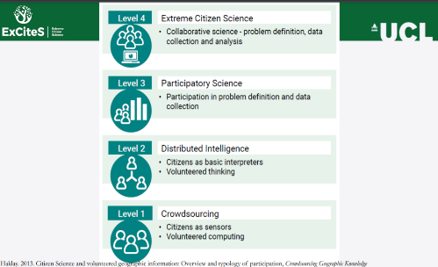
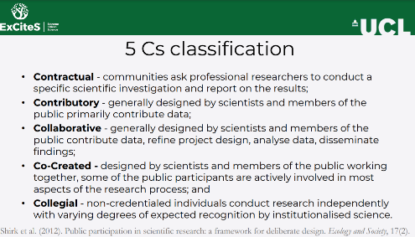
Partire dal basso, almeno che siate già esperti:
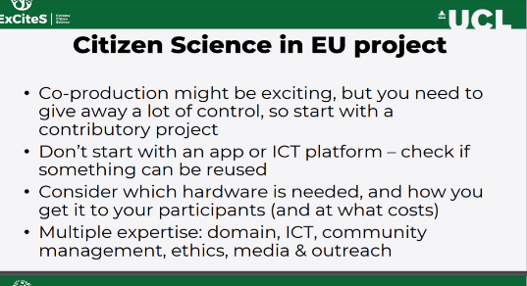

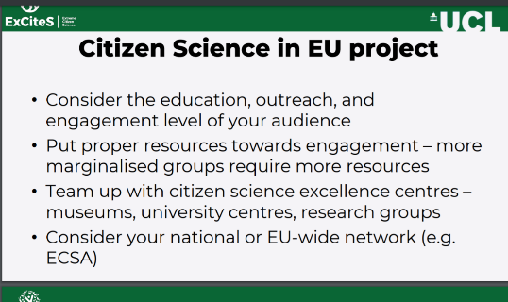
Guiding questions (https://actionproject.eu/toolkit/ ):
In defining and framing the problem, projects should consider the following questions:
- What is the issue at the heart of the project? Why should people care about it?
- Is the project timely? Has the issue been addressed before, and if so, why is now a good time to do so again?
- Who are the relevant stakeholders? Who would have an interest in this issue, and why? Who will be impacted if the project finds a solution to the problem?
- What are the geographic boundaries of the issue / the project? A problem such as air pollution can be global but be addressed locally, or on a wider scale. The intended scale has implications for the design of the project.
- What is the timeframe of the project; is there a set deadline, or is it going to be a continuous effort?

Questions projects should ask when planning their engagement strategy include:
- Who will be affected by the research, and who will be interested in it? What other stakeholders are there?
- Who do they want to engage in the project? How can they reach these individuals / communities?
  - Who is not included yet, who will be hardest to reach and why, and how can they be included in the project?
  - What are limitations of the project if not all stakeholders can be involved?
- What will motivate people to engage in the project?
  - Should engagement focus on intrinsic or extrinsic motivation?
- What is the best way to engage people for this specific project?
  - What tools would be useful to achieve this?

In designing their citizen science research design, projects should consider the following questions:
- What resources do you need to implement and run this project, and how will you access them?
- You could look into support or funding programs for citizen science, or look into free tools and resources that you can use.
- What expertise do you have, and what are you missing? How will you fill those gaps?
- This could be by learning about aspects of the project yourself, by finding volunteers or paid services, or partnering with individuals or organisations who can provide them.
- Are there any individuals or organisations you could partner with, and for what purposes?
- You could reach out to researchers at local universities, NGOs with goals similar to yours, or councillors with a political interest in the issue you are investigating.
- Where and how will citizen scientists be involved throughout the project? What contribution can they make? How will you engage with them?
- Citizens could be involved only for data collection, for example by using an app you provide them with; or they could be involved in the entire process, advising the project on key questions and issues.
- What data do you need to collect to answer your research question? How much data will you need? What will you do with it?
- What is the best way to collect the data required to answer the research questions?
- What tools will you use to collect the data? How will you ensure data quality?

Esempi:
- Life Sciences (LS): DreamLab https://www.vodafone.it/nw/vodafone-italia/fondazione-vodafone-italia/attivita/progetti/dreamlab.html
- Physics, engineering, math (PE): Gravity spy https://www.zooniverse.org/projects/zooniverse/gravity-spy
- Social sciences and humanities (SH): MHS project https://www.zooniverse.org/projects/mainehistory/beyond-borders-transcribing-historic-maine-land-documents
Link utili:
- https://ecsa.citizen-science.net/
- https://ec.europa.eu/digital-single-market/en/citizen-science
- https://eu-citizen.science/
- https://medies.net/wp-content/uploads/2020/07/CitizensScience_Factsheet_Final.pdf
- https://www.zooniverse.org/

ANNEX 2
OPEN SCIENCE and DATA MANAGEMENT PLAN
Open Science Practises
The Università degli Studi di Milano (UMIL), as coordinator, will supervise, advise and monitor open science practises implementation at all levels through the research and innovation chain thanks to a constant exchange with consortium members and project officers. UMIL translates its vision into specific policies, documents, and dedicated personnel supporting the realization of practices related to open access, open data, research data management and FAIR data, data privacy, research integrity, training and monitoring: https://www.unimi.it/en/research/research-data-and-outputs/open-science.
UMIL collects and makes available research products through its institutional repository AIR (air.unimi.it) and makes accessible research data through the dataverse repository (dataverse.unimi.it)
The university/company/…..completare con strumenti e politiche di open science in altri enti del consorzio
The consortium members agrees that scientific publications will be published in open access gold journals and in the case of hybrid journals will be made known to the publisher the obligations to publish the AAM at the same time as the publication of the article in institutional certified repositories (RRS). Consortium members will undoubtedly take into consideration the opportunity offered by Open Research Europe, since the mechanism of submission validation and evaluation is considered virtuous and transparent.
The possibility of publishing in dedicated preprint archives (such as…..) will be taken into consideration.
Research data will be treated according to FAIR principles and according to the principle “as open as possible, as closed as necessary”.
In the case of confidential data, agreements with consortium members will always provide for the accessibility of the data to those who make a justified request, and the DMP will provide detailed information on how access will be granted.
In summary the whole consortium supports openness and FAIR data management as a fundamental value that cuts across all research-related activities and vital for reaching project objectives.
We expected that….
Qui cercare di declinare come le pratiche di open science contribuiranno al raggiungimento degli obiettivi di progetto, del topic e della destination più in generale. Per esempio: open access vuol dire più download, più citazioni, più circolazione della conoscenza e quindi più collaborazioni e sinergie che possono crearsi tra persone e progetti per arrivare ad un obiettivo comune più grande. Qui siate specifici e indicate quali obiettivi, quali e quante collaborazioni potrebbero crearsi, etc.
Nasceranno nuovi progetti a cascata che permetteranno di costruire sui risultati ottenuti in questo progetto e garantire un impatto nel breve, medio e lungo termine. Anche qui siate specifici dando esempi quali- e quantitativi.
Open data e un buon data management plan vogliono dire riproducibilità dei risultati e una più facile circolazione del metodo che svilupperete e una credibilità maggiore dei risultati per chi dovrà poi riconoscerli, adottarli e diffonderli come standard. O utilizzarli per lo sviluppo di un prodotto. Anche qui calate questo aspetto nello specifico del vostro progetto.
Open science (come citizen science e stakeholder involvement) vuol dire avere un feedback immediato sulla rilevanza degli obiettivi progettuali per chi sarà il fruitore finale. Anche qui siate specifici nell’indicare quali stakeholder potrebbero dare un feedback interessante e su quali aspetti e un accenno a come tale feedback verrà preso in considerazione nell’implementation del progetto.
La domanda principe da farsi è: se non metto in atto pratiche di open science, quali obiettivi di progetto rischio di non raggiungere o di raggiungere parzialmente? Provate a scrivere qualcosa e poi lo rivediamo insieme

Research data management
The Consortium will produce ………….
Specificare le tipologie di dati se numerici testuali o altro Magari le modalità con cui saranno prodotti e una stima della quantità in giga, terabyte ecc.
Se saranno utilizzati dati preesistenti dire quale sarà la provenienza, secondo quali accordi e se saranno necessarie attività di data cleaning
Persistent identifier will be used for researchers (ORCID) and datasets (DOI) and data will be deposited in trusted repositories such as Dataverse.unimi.it (elencare qui eventuali altri repository delle altre istituzioni.)
Dataverse.unimi is an institutional data repository for FAIR data indexed in Open AIRE and Re3Data.
Datasets will be described using the Dublin core metadata scheme and where applicable standard ontologies will be used.
The Consortium will make all data accessible and will respect the principle as open as possible as closed as necessary
if specific datasets will require confidential treatment (e.g. for patenting) this will be regulated by specific agreements between the partners
If restrictions are applied, a justification will be given and clear instructions on how access to data will be guaranteed to anyone who makes a justified access request (officers, reviewers, researchers etc) for verification and validation processes
If the data will be open, the license for its use will also be indicated (preferably CC0 or CC BY)
Specificare poi quali saranno le metodologie utilizzate egli strumenti per la produzione dei dati e cosa si prevede per la conservazione a breve termine (onedrive di ateneo per unimi) e a lungo termine Dataverse.
Specificare anche quali sono le modalità con cui garantirete la qualità dei dati.
Costs for storage and preservation will be defined in the data management plan and the Consortium will evaluate the possibility to enroll a data manager

ANNEX 3
IMPACT
Riportiamo alcune slide esplicative fornite da APRE (Agenzia Per la Promozione della Ricerca Europea)

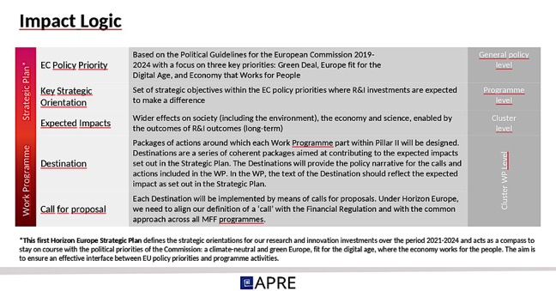

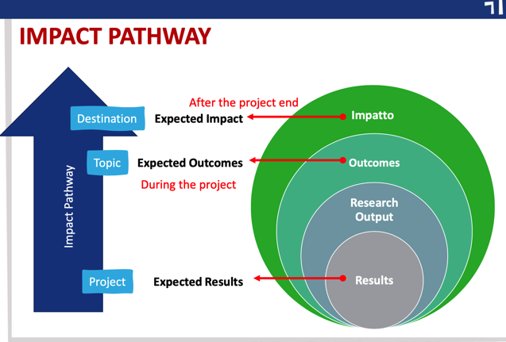

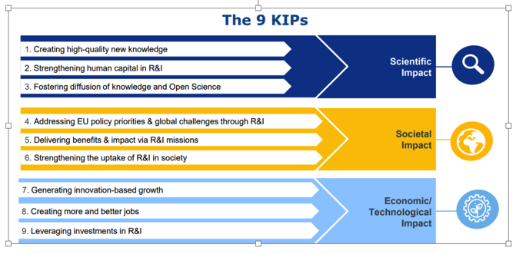

ANNEX 4
PATHWAY TO IMPACT summary table
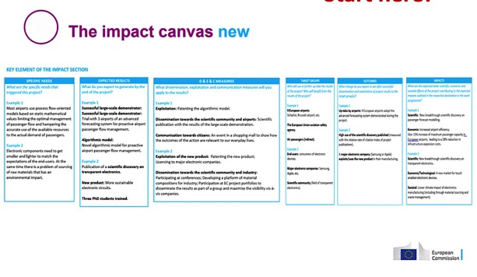

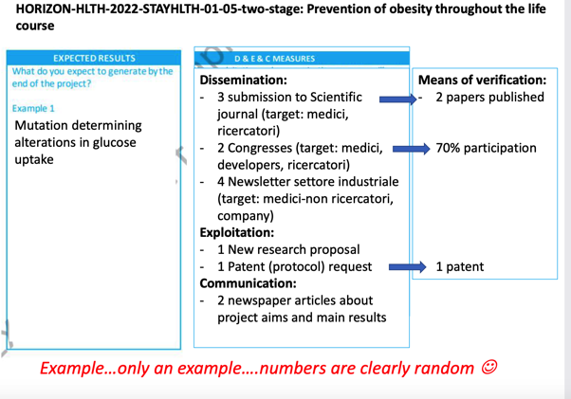
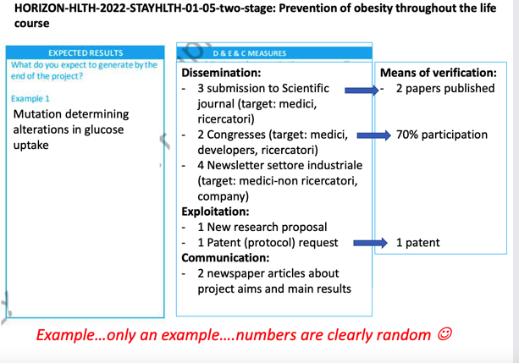

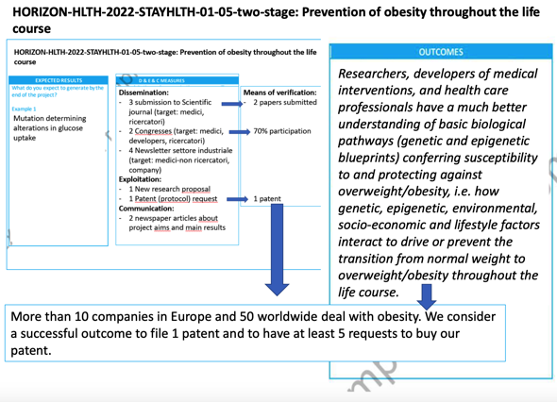

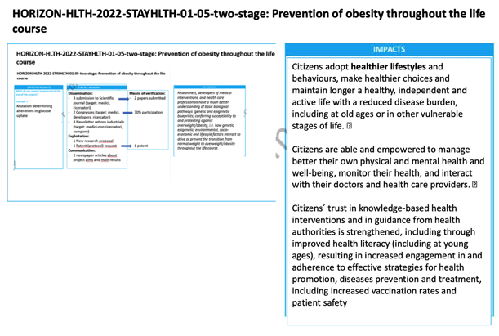

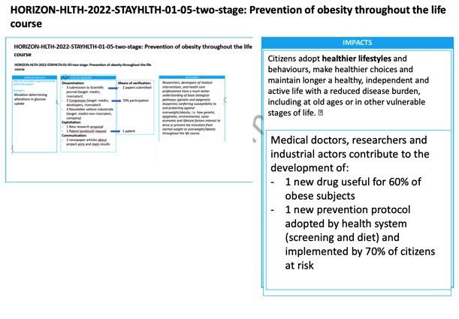

For further guidance on communicating EU research and innovation for project participants, please refer to the Online Manual on the Funding & Tenders Portal
You must include a data management plan (DMP) and a ‘plan for dissemination and exploitation including communication activities’ as distinct deliverables within the first week and the first 6 months of the project respectively. The DMP will evolve during the lifetime of the project in order to present the status of the project's reflections on data management. A template for such a plan is available in the Online Manual on the Funding & Tenders Portal.

